**Help.com**

**FYP-I Report**

**BS(CS) FALL 2024**

**Awesh Kumar**

**21K-4526**

**Anil Kumar**

**20K-0444**

**Danish Nanijiani**

**21K-3959**



**Supervisor: Ms. Zain Noreen**

**Department of Computer Science**

**FAST-National University of Computer & Emerging Sciences, Karachi**

**Content**

1.Introduction.....................................................................................................................3

2.Related Work..................................................................................................................3 3.Methodology...................................................................................................................4

4.Testing and Results........................................................................................................4

5.System Diagram.............................................................................................................7

6.Goals For FYP-II....................................................................................................…….7

7.Conclusion..............................................................................................................……8 8.References.................................................................................................................... 8

**1.Introduction**

Help.com is an all-encompassing social welfare platform designed to connect communities through acts of kindness, charity, and volunteerism.

This innovative platform bridges the gap between those in need and individuals or organizations eager to make a difference. By offering features such as item donations, help requests, and volunteer opportunities, Help.com simplifies the process of giving and receiving aid, fostering a collaborative and compassionate environment.

Through advanced web technologies and user-friendly design, Help.com provides a seamless experience for donors, recipients, and volunteers alike. With a focus on transparency, efficiency, and accessibility, the platform empowers communities to come together and create meaningful change.

**2.Related Work**

In the development of the Help.com , we referred to several Software Requirements Specifications (SRS) and Software Design Specifications (SDS) to ensure a structured and systematic approach. This section outlines the findings from related work and the methodologies adopted to frame our project.

**Existing Platforms:**

Several platforms currently exist to facilitate charitable activities and volunteering, each with its unique focus and features. Platforms like GoFundMe, which specializes in crowdfunding for various causes, and VolunteerMatch, which connects users with volunteer opportunities, served as reference points for our project. These platforms offered valuable insights into essential features such as user engagement, opportunity postings, and donation management systems, which were adapted and enhanced in the development of Help.com to create a more holistic and streamlined experience

**Software Requirement Specifications(SRS):**

The SRS documents reviewed emphasized the importance of clear, concise, and comprehensive requirement gathering. Key components of a robust SRS include:

**1.Functional Requirements:** Detailed descriptions of user interactions, product management, order processing, and payment systems.

**2.Non Functional Requirements:** Performance metrics, security protocols, and usability considerations.

**3. Design Constraints:** Platform dependencies, scalability issues, and integration with third-party services.

**Software Design Specifications(SDS):**

The SDS documents provided guidance on the architectural design and technical implementation of the project. Key aspects included:

**1.System Architecture:** Client-server architecture, microservices, and database management systems.

**2. Component Diagram:** Visual representation of system components and their interactions.

**3. Use case Diagrams:** Detailed scenarios of user interactions with the system, providing a clear understanding of functional requirements.

**3.Methodology**

The development of Help.com, a social welfare platform, follows a structured methodology, blending agile and traditional software development practices to ensure flexibility and discipline.

**Requirement Analysis:**

**Stakeholder Engagement:** Regular meetings with volunteers, NGOs, and beneficiaries to gather and refine requirements.

**Market Research:** Analysis of existing social welfare platforms to identify key features and potential improvements.

**Design:**

**System Architecture:** A scalable client-server architecture using the MERN stack for robust performance and easy maintenance.

**Component Diagrams**: Developed to depict high-level components, including user management, donation logistics, volunteer management, and admin dashboards.

**Development:**

**Agile Methodology:** An iterative development process with bi-weekly sprints to deliver features and receive continuous feedback.

**Technology Stack:** Utilization of React.js for the frontend, Node.js for the backend, and MongoDB for the database.

**4.Testing and Result**

Given the current status of Help.com, testing focused on completed modules while identifying issues in incomplete or non-functional components.

**Unit Testing**

**Purpose:** Ensure individual functions and components work correctly in isolation.

**Method:** Each function and module was tested independently using specific test cases.

**Results:**

**User Authentication Module:**

1. **Test:** Registration, login, and authentication processes.
2. **Result**: Failed. User authentication is not working.

**Donation Management Module:**

1. **Test**: CRUD operations for donations.
2. **Result:** Passed Donations were successfully created, updated, and deleted.

**Volunteer Management Module:**

1. **Test:** CRUD operations for volunteer tasks.
2. **Result**: Passed Volunteers’ schedules and tasks were successfully managed.

**Admin Dashboard Module:**

1. **Test**: Access and data management.
2. **Result**: Passed. Admin functionalities operated as expected.

**Integration Testing**

1. **Purpose:** Verify that different modules and components work together seamlessly.
2. **Method:** Tested interactions between frontend and backend and among various modules.

**Results:**

**API Integration:**

1. **Test:** Interaction between frontend and backend APIs.
2. **Result:** Failed. APIs are not fully connected.

**Donation Logistics Module:**

1. **Test:** Integration of donation posting, volunteer management, and notifications.
2. **Result**: Partially Completed. Integration needs improvements.

**System Testing**

1. **Purpose:** Validate the complete and integrated platform to ensure compliance with the project’s requirements.
2. **Method**: Conducted end-to-end testing of major user flows.

**Results:**

**User Experience:**

1. **Test:** End-to-end journey from posting donations to successful delivery.
2. **Result:** Passed. Users could browse, post donations, and schedule pickups.

**Functional Requirements:**

1. Test: Verification of specified platform features.
2. Result: Partially Passed. All requirements were met except for user authentication and API integration.

**User Acceptance Testing (UAT)**

Purpose: Ensure the platform meets end-users’ expectations.

Method: Conducted beta testing with selected volunteers and donors, gathering feedback.

**Results:**

**User Feedback:**

1. Test: Evaluate usability and platform navigation.
2. Result: Passed. Positive feedback on completed modules, especially donation and volunteer management.

**Minor Adjustments:**

1. Test: Implement changes based on feedback.
2. Result: Passed. UI improvements enhanced overall user experience.

**5.System Diagram**

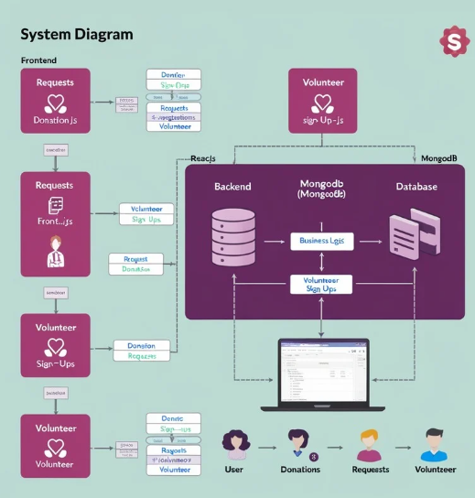

1. **Goals of FYP-II**
2. Front-end::
3. Develop front-end for Admin, Donation Logistics , Get Involved.
4. Enable image, description, and payment systerms etc .
5. Advanced Feature Implementation:
6. Optimize tailored algorithms.
7. Integrate social media sharing features.
8. Comprehensive User Testing:
9. Conduct extended beta testing.
10. Integrate user feedback.
11. Front-End and Back-End Connection:
12. Ensure seamless API integration.
13. Implement real-time data synchronization.
14. Final Presentation and Launch Preparation:
15. Fix bugs and refine UI/UX.
16. Prepare documentation and reports.
17. Plan and execute the Web host.

**7.Conclusion**

The development of Help.com has followed a well-structured methodology, emphasizing user-centric design, scalable architecture, and efficient module integration. By aligning with clearly defined Software Requirements Specifications (SRS) and employing agile development practices, the platform has evolved into a robust, feature-rich social welfare platform.

Despite challenges such as incomplete user authentication and partial API integration, substantial progress has been made. Modules like donation management, volunteer tracking, and the admin dashboard have been successfully implemented, demonstrating functionality and user satisfaction. Feedback from initial testing has been encouraging, highlighting the platform’s potential to simplify charitable activities and foster community engagement.Looking ahead, the next development phase will focus on completing critical modules, refining API integrations, enhancing performance, and introducing additional features like real-time notifications and AI-powered support. These enhancements will ensure Help.com meets its mission of connecting donors, volunteers, and organizations for a greater social impact.

In conclusion, Help.com is on track to become a transformative platform in Pakistan's social welfare landscape. By leveraging modern technology, it aims to bridge gaps between those willing to help and those in need, creating a seamless, transparent, and impactful social assistance network.

**References:**

1. Steele, J., and Adams, D., Full Stack React, Node, and MongoDB: Learn to Build Modern Web Applications, Addison-Wesley, Boston, 2019.

2. https://www.gofundme.com

3. https://www.charitynavigator.org